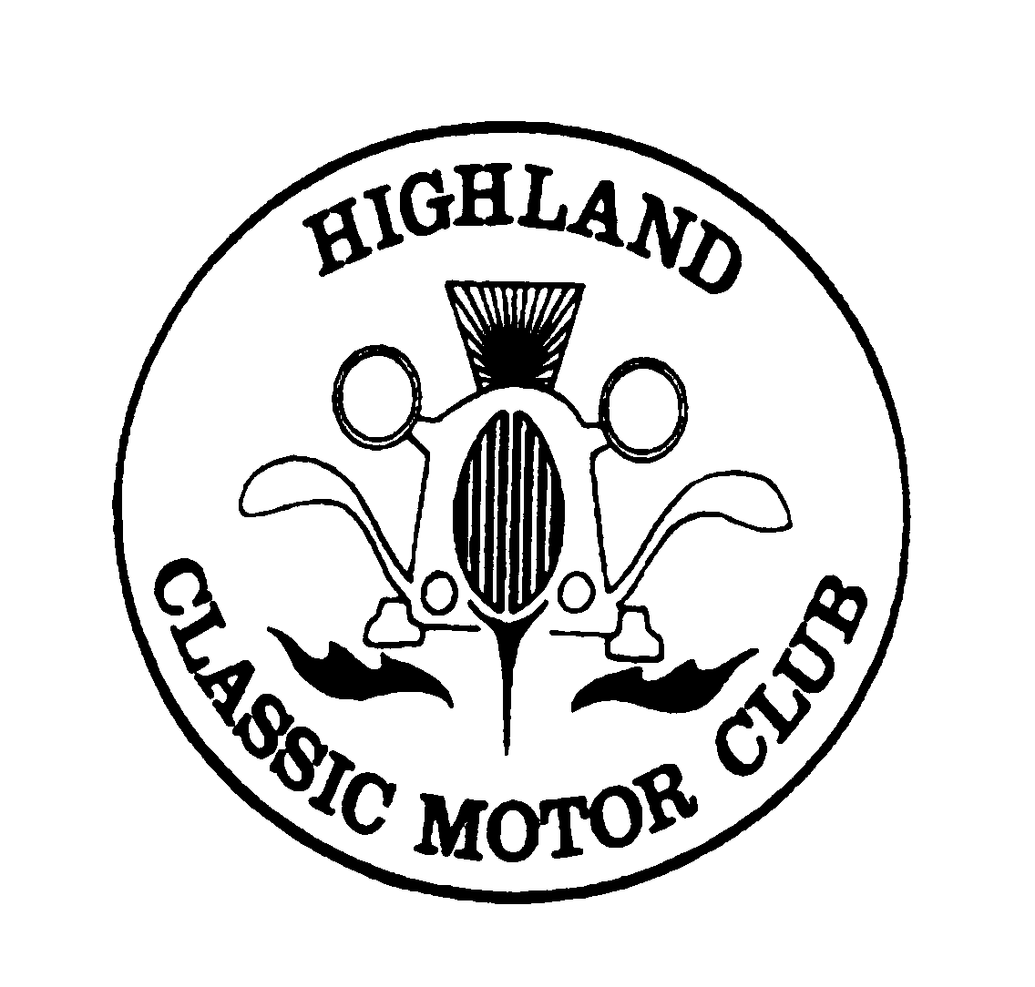
Highland Classic Motor Club.
Minutes of the Annual General Meeting
1 February 2024 at the Old North Inn, 7pm

Appologies: Ian Beaton, Graeme Jamieson, Graeme Bremner, Roy MacGregor.

Members present: John Stott, Roddie Main, Michael Fraser, Ranald Smith, Tom McCallum, Bryan Mcilwraith, Trish Brown, Richard Lashley, Alice Brown, Callum Beveridge, Miles Vincent, Calum Pearson, Ian McNeill

Minutes of the last AGM were passed with a minor amendment. Proposed: Alice. Seconded: Tom

President’s report. Trish welcomed everyone at the meeting. She briefly recapped the activities of the past year and observed that the club continues to offer its members an interesting mix of meets, runs and visits.

Treasurer’s report. In the absence of the Treasurer, Trish was able confirm that she had inspected the accounts for 2023 and these were found to be in order. At the end of December 2023, the club had £2,837.07 in the bank.

(Members) Secretary’s report. Paid membership is slightly up from last year to 86. A discussion ensued following comments that some people find it difficult to join up. Agreed that the committee would look into this further with a view to improving the joining process if required.

Election of office bearers:
Chair: Richard Lashley, proposed Bryan, seconded Callum. Richard accepted the post.

Secretary: Trish Brown, proposed: Alice, seconded: Calum

Members secretary: Miles Vincent, unanimously accepted by membership.

Treasurer: Ian Thomson, unanimously accepted by membership.

Webmaster: Callum Beveridge, unanimously accepted by membership. Callum indicated that this would be his last year as webmaster. Trish suggested that he documents how the website is build/functions so that this can be passed on to a new webmaster next year.

Editor: Calum Pearson, unanimously accepted by membership. Calum Pearson indicated that he too would like to step down as Editor, but will continue with more support from the membership. He suggested an editorial team to assist him with collating articles for the magazine in order to reduce the time required to produce the actual magazine. Ranald and Miles offered their assistance.

Ordinary committee members: Roy MacGregor, Ranald Smith, Bryan McIlwraith and Graeme Bremner, unanimously accepted by the membership.

AOCB
Miles summarised the presents and monies gathered by the club and at Cars & Coffee for MFR Cash for Kids. He also mentioned the favourable publicity that the club received for its efforts.

A suggested activities for this year was an AutoJumble and a weekend run. This generated a deep discussion on what may be permitted under our public liability insurance and whether there are any obligations on the said insurance, for example risk assessments. Agreed was that the committee would look further into this. If required risk assessments will be published under the Committee Documents.

Agreed that the committee will meet shortly to set this years calendar of meetings.

Agreed that the club will fund refreshments for this year’s Drive It Day.

March meeting will be a quiz (Trish). The venue for the meeting will be confirmed in the March magazine.

The AGM closed at 8.55pm.

